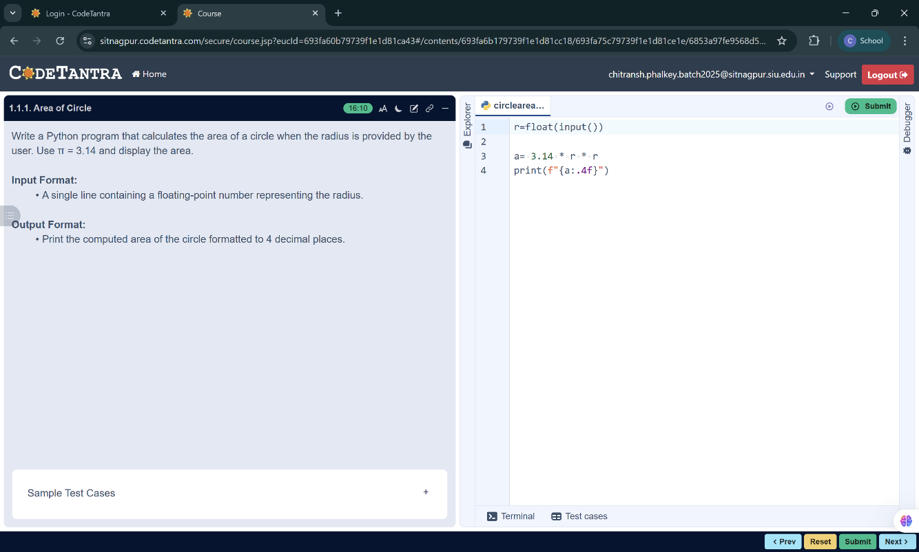
    - Area of Circle
Write a Python program that calculates the area of a circle when the radius is provided by the user. Use π = 3.14 and display the area.

Input Format:
- A single line containing a floating-point number representing the radius.

Output Format:
- Print the computed area of the circle formatted to 4 decimal places.
Flowchart

Start
ALGORITHM
- Start
- Read the radius r from the user
Input Radius
- Set the value of π = 3.14
- Calculate the area of the circle using the formula
- $\text{Area}=3.14×r×r$
- Display the calculated area formatted to 4 decimal places
- Stop
STOP
Print area
area = 3.14 × r × r

